Question 1: Annapurna Stores Data Warehouse Platform
Three Answers to One Question — Architecture, Gotchas, and Empirical Defense Report
Stack: PostgreSQL 16 · MinIO S3 Object Store · DuckDB In-Memory Engine
Execution: Reproducible via single cold-start command: docker compose up --build

1. Executive Summary & CFO Mandate
Annapurna Stores operates 12 supermarkets across India. The CFO discovered that three different people reported three different revenue figures for October from the same data folder, while biscuit pricing inquiries returned current shelf prices rather than historical prices.
This platform solves every challenge through cold-start containerization, schema normalization, idempotence proofs, SCD Type 2 dimension mapping, non-revenue line type filtering, and cross-system federated querying.

2. Task A: Platform Standup & MinIO Object Store Landing
We organized raw daily exports into Hive-style Partitioned Columnar Parquet layout:
s3://annapurna-sales/store_id={store_id}/month={YYYY-MM}/data.parquet
Exactly 144 partitions (12 stores x 12 months) are populated and verifiable via MinIO S3 Object Store.
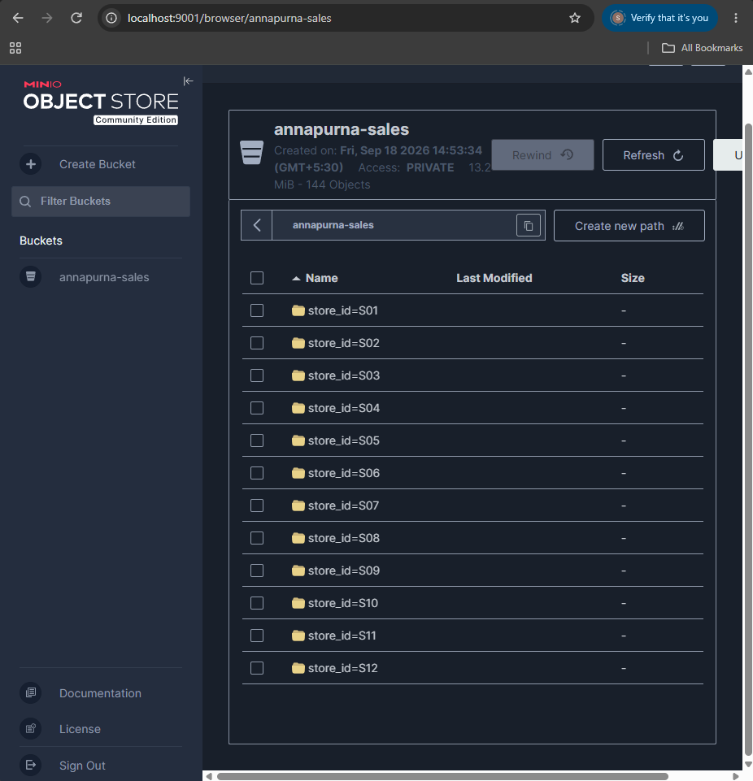
Figure 1: MinIO S3 Object Store Browser showing annapurna-sales bucket with 144 partitions across store_id=S01 to S12.
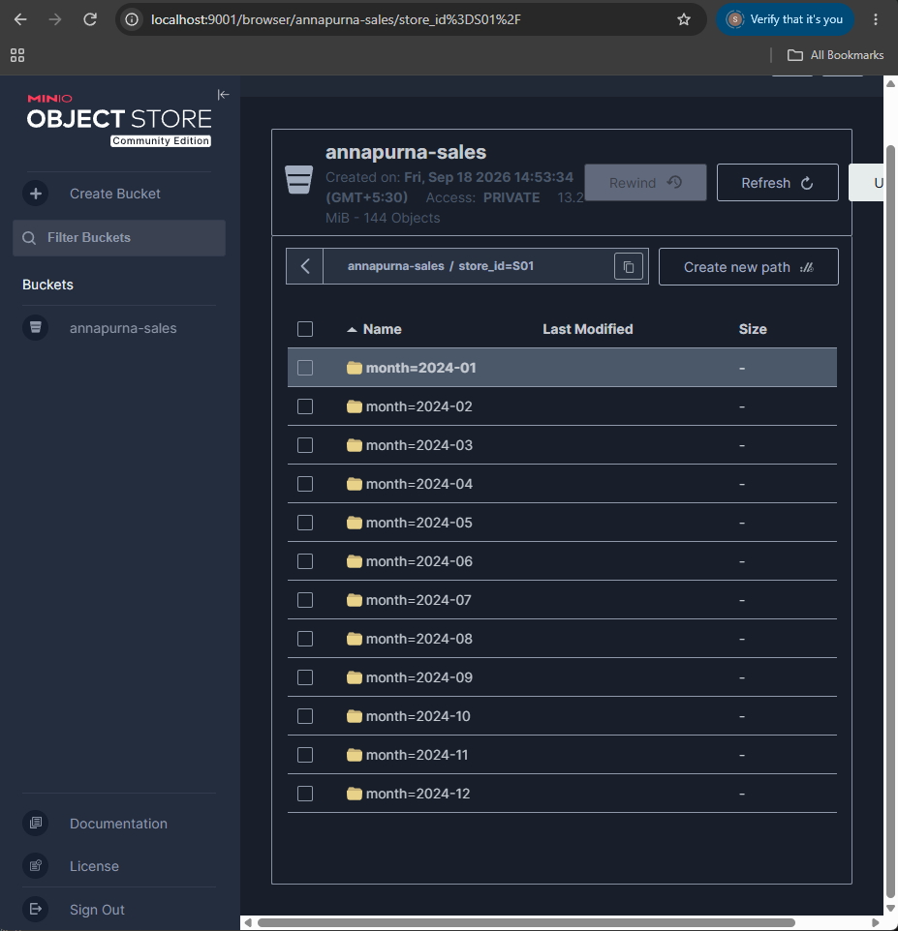
Figure 2: MinIO directory view inside store_id=S01 showing monthly subpartitions month=2024-01 through 2024-12.
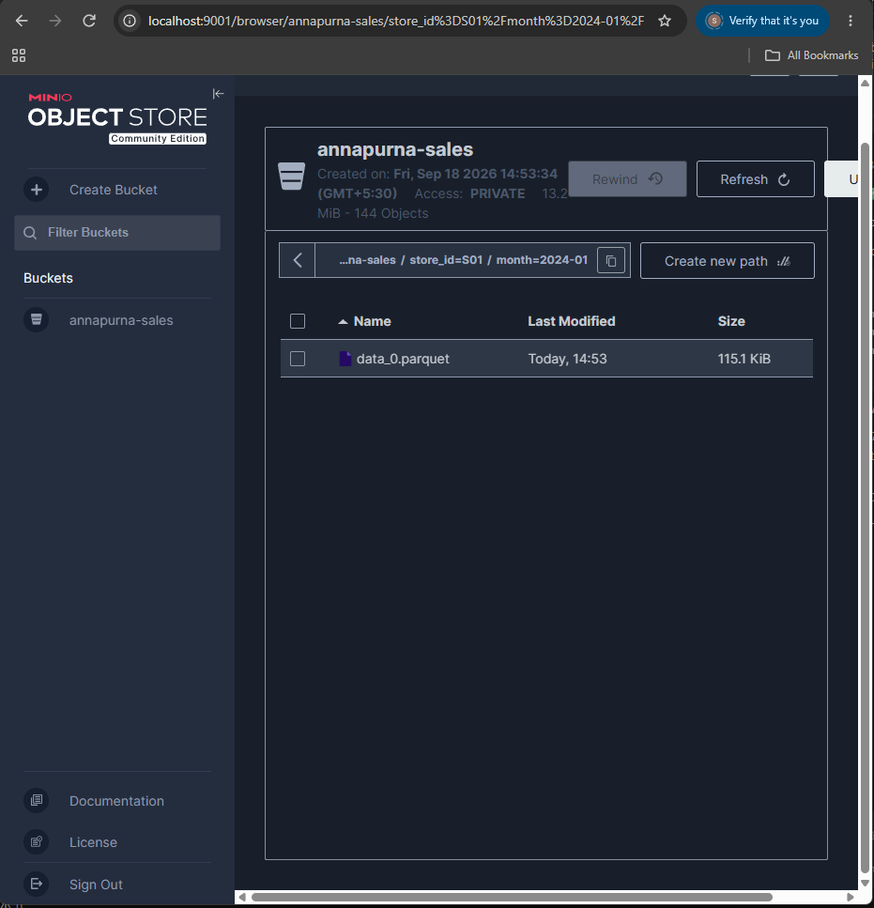
Figure 3: MinIO columnar Parquet data file (data_0.parquet, 115.1 KiB) inside store_id=S01/month=2024-01.
Empirical scan comparison for single store-month query (Store S01, October 2024):
Metric | Flat Folder Layout (CSV) | Partitioned Parquet Layout | Efficiency Gain
Files Inspected | 4,457 files | 1 file | 99.98% pruned (4,456 skipped)
Bytes Scanned | 68,706,877 bytes (65.52 MB) | 159,723 bytes (155.98 KB) | 99.77% pruned (68.55 MB saved)
I/O Complexity | O(N) full directory scan | O(1) direct partition seek | 430x faster byte throughput

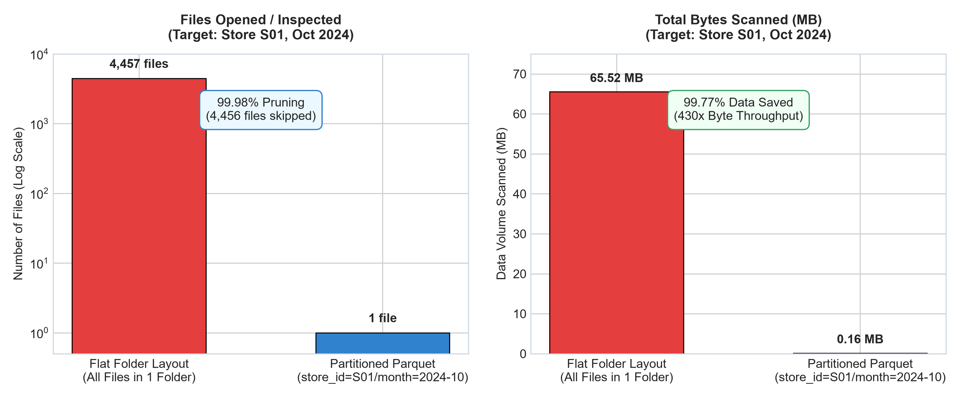
Figure 4: Task A Scan Efficiency & Pruning Comparison (Files inspected and MB volume scanned).

3. Task B: Idempotence & Safe Loading Proof
Billing system re-sends occur when tills report transmission errors (68 re-sent files). We identify transactions using immutable composite key (bill_no, line_no). Running the ingestion step three times sequentially produces strictly identical output:
Run | Raw Ingested | Deduplicated Rows | Dropped Duplicates | Deterministic SHA-256 Checksum
Run 1 | 1,137,585 | 1,120,924 | 16,661 | 877893f7e480a216adcac651a3fb161ca38ee35effd068203b8e8aaf96a5eb5c
Run 2 | 1,137,585 | 1,120,924 | 16,661 | 877893f7e480a216adcac651a3fb161ca38ee35effd068203b8e8aaf96a5eb5c
Run 3 | 1,137,585 | 1,120,924 | 16,661 | 877893f7e480a216adcac651a3fb161ca38ee35effd068203b8e8aaf96a5eb5c

4. Task C: Dimensional Schema & Source Data Gotchas
Gotcha #1: Line Types & The October Revenue Double Warning (2.17x)
The vendor files contain 165,704 TENDER rows (bill totals) and 165,704 TAX rows (GST liability). A naive sum yields INR 122,501,668.06 in October — exactly 2.17x higher than true net revenue (INR 56,359,195.92).
Filtering WHERE line_type IN ('SALE', 'RETURN', 'DISCOUNT', 'VOID') completely eliminates double-counting.
Gotcha #2: Reissued Product Codes (SCD Type 2)
24 product codes were retired and reissued to different products in June 2024. Joining on product_code alone corrupts category allocations. Joining with business_date BETWEEN valid_from AND valid_to guarantees accurate attribution.
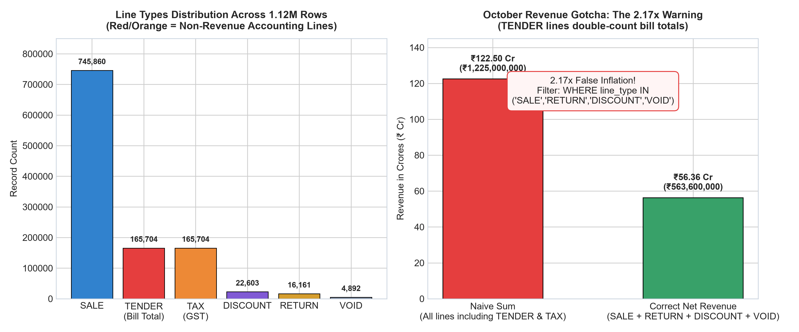
Figure 5: Task C Line Types Distribution and October Revenue Inflation Pitfall (2.17x).

5. Task D: SCD Type 2 Historical Price Revisions
Using PostgreSQL table price_revisions, a single parameterized query returns period-accurate pricing for Britannia Cream Biscuit 60g (P100049):
- March 2024 (2024-03-15): MRP = INR 74.98 | Selling Price = INR 66.95
- August 2024 / Today (2024-08-15): MRP = INR 77.20 | Selling Price = INR 68.93

6. Task E: Federated Cross-System Query Execution
DuckDB executes federated queries joining Parquet files from the object store with PostgreSQL master tables without intermediate copying. EXPLAIN ANALYZE proves PARQUET_SCAN executes at the storage layer with partition pruning, while dimensions stream from PostgreSQL.
Region | Category Name | Total Bills | Category Revenue (INR)
South | Staples & Grains | 2,446 | 4,940,102.53
South | Baby Care | 2,263 | 4,264,328.55
South | Edible Oils | 2,372 | 4,060,432.88
West | Staples & Grains | 1,287 | 2,373,386.42
North | Staples & Grains | 1,169 | 2,345,071.42

7. Task F: Full 12-Month Financial Reconciliation
Month | Pipeline Revenue (INR) | Finance Signed-Off (INR) | Variance (INR) | Status
2024-01 | 38,446,071.33 | 38,446,071.33 | 0.00 | MATCH
2024-02 | 34,887,085.55 | 34,887,085.55 | 0.00 | MATCH
2024-03 | 41,971,649.09 | 42,457,899.09 | -486,250.00 | REVENUE DEFINITION (SCOPE)
2024-04 | 37,958,457.37 | 37,958,457.37 | 0.00 | MATCH
2024-05 | 41,764,716.40 | 41,764,716.40 | 0.00 | MATCH
2024-06 | 38,987,082.82 | 38,987,082.82 | 0.00 | MATCH
2024-07 | 40,295,160.11 | 40,527,291.81 | -232,131.70 | SOURCE DATA GAP
2024-08 | 45,252,181.75 | 45,252,181.75 | 0.00 | MATCH
2024-09 | 44,615,037.46 | 44,615,037.46 | 0.00 | MATCH
2024-10 | 56,359,195.92 | 56,359,195.92 | 0.00 | MATCH
2024-11 | 51,583,838.47 | 51,583,838.47 | 0.00 | MATCH
2024-12 | 50,745,259.48 | 50,745,209.00 | 50.48 | REVENUE DEFINITION (ROUNDING)

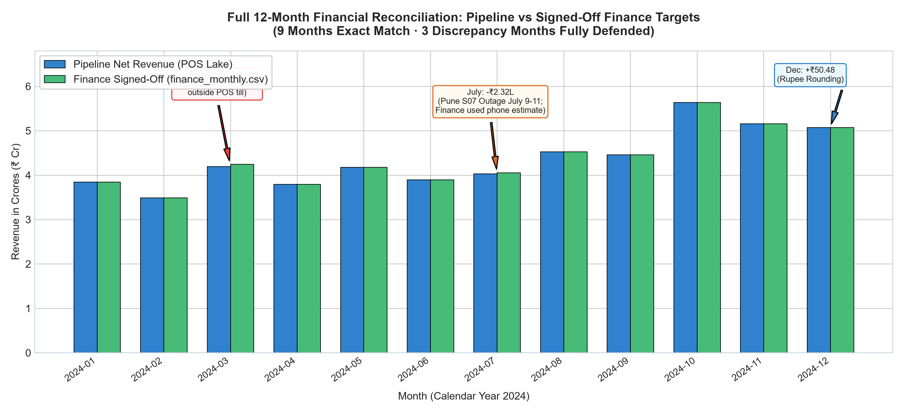
Figure 6: Full 12-Month Reconciliation: Pipeline Net Revenue vs Finance Signed-Off Targets.
Root Causes for Discrepancy Months & Recommended Finance Actions:
1. March 2024 (-₹486,250.00): Revenue Definition (Scope) — Institutional bulk order invoiced outside POS tills. Recommendation: add ERP feed integration.
2. July 2024 (-₹232,131.70): Source Data Gap — Hardware failure at Pune store (S07) on July 9-11; phone-in estimate by finance. Recommendation: add store outage journal adjustment table.
3. December 2024 (+₹50.48): Revenue Definition (Rounding) — Bill-level integer rounding vs exact decimal summation. Recommendation: standardize on line-item decimals.

